Design Document
cpu_emu
(In Development)

Joseph MacDonald
Independent Project

Contents
Table of Contents
Contents 2
Section 1 - ISA Design 3
1. Instruction and Data Design 3
a. Notes 3
b. Instruction Formats 4
Section 2 – Emulated System Design 5
1. Finite State Machine Design 5
2. Data Handling Design 7
Section 3 – Emulator Design 8

Section 1 - ISA Design

Instruction and Data Design

Notes
Instr/Data Bit of 1 indicates presence of an instruction
Reg/Literal Bit of 1 indicates the presence of a register reference
All instructions and data are stored in 64-bit chunks
Memory is referenced using 32-bit addresses
All 64-bit data values are stored in Two’s Complement form
ASCII-bit indicates whether data should be output in an ASCII form

Instruction Types
Type | Format | Description | Examples
ADD | Type 1 | Performs addition on two input values, stores in specified register. Can take either register or literal operands | ADD R0, R1, R2  ADD R1, R1, #10  ADD R10, #15, #23
SUB | Type 1 | Subtracts second value from first, stores in specified register. Can take either register or literal values as operands | SUB R0, R5, R4  SUB R0, #100, R7  SUB R9, R6, #10
MULT | Type 1 | Multiplies two values together, stores in specified register. Can take register or literal operands. In effect, repeat addition for specified amount | MULT R7, R4, R2  MULT R4, #42, R9  MULT R4, R6, #9
AND | Type 1 | Performs a bitwise AND operation on the two input values. Stores in specified register, can take register or literal operands | AND R0, R2, R9  AND R3, #12, R9  AND R5, #12, #34
OR | Type 1 | Performs a bitwise OR operation on the two input values. Stores in specified register, can take register or literal operands | OR R3, R3, R4  OR R5, #92, #100  OR R7, #12, R1
XOR | Type 1 | Performs a bitwise XOR operation on the two input values. Stores in specified register, can take register or literal operands | OR R6, R11, R2  OR R12, #99, R1  OR R7, #104, R4
NOT | Type 2 | Performs a bitwise NOT operation on the input. Stores in specified register, can take a register or literal operand | NOT R1, R1  NOT R10, #2
FLIP | Type 2 | Flips the sign of the input, be that literal or register | FLIP R4, R8
STR | Type 3 | Stores specified register contents at the memory address supplied | STR R2, &1223ABCD  STR R0, &A1B2C3D4
LDR | Type 3 | Loads the value stored at the specified memory address into the register supplied | LDR R5, &AEEC1442  LDR R8, &12345678
CMP | Type 4 | Compares two input values, setting ALU flags but not changing the value in any register. Can take literal or register inputs | CMP R4, R7  CMP #9, R2  CMP R10, #0
B | Type 5 | Performs a branch operation, setting the PC to the position specified address if any conditions are met. Find branch conditions in table ‘c. Branch Conditions’ | B &ABCD1234  BNE &12344321  BLT &FFECFDDA
HLT | Type 6 | Stops the clock, ending any running operations | HLT
OUT | Type 7 | Outputs the value in the specified register to an external file. Will output in ASCII form if the ‘A’ flag is set | OUT R R7  OUT A R1

Instruction Formats

Type 1 – Arithmetic & 2-Operand Bitwise Operations
[Instr Type]{4} [Return Register]{4} [Reg/Literal Bit 1] [Reg Reference/Literal Value]{16} [Reg/Literal Bit 2] [Reg Reference/Literal Value]{16} [Padding]{20}

Type 2 – Single-Operand Bitwise Operations
[Instr Type]{4} [Return Register]{4} [Reg/Literal Bit 1] [Reg Reference/Literal Value]{16} [Padding]{40}

Type 3 – Memory Operations
[Instr Type]{4} [Referenced Register]{4} [Memory Address Reference]{32} [Padding]{24}

Type 4 – Comparator Operations
[Instr Type]{4} [Reg/Literal Bit 1] [Reg Reference/Literal Value]{16} [Reg/Literal Bit 2] [Reg Reference/Literal Value]{16} [Padding]{24}

Type 5 – Branch Operations
[Instr Type]{4} [Branch Condition]{4} [Memory Address Reference]{32} [Padding]{24}

Type 6 – Control Operations
[Instr Type]{4} [Padding]{60}

Type 7 – Output Operations
[Instr Type]{4} [Target Register]{4} [ASCII Bit] [Padding]{54}

Section 2 – Emulated System Design

Finite State Machine Design
State | No. | Description/Steps | Next State(s)
Fetch | 0 | Retrieve next instruction from memory  Call cache  - If cache hit – Decode Instruction  - If cache miss – Stall, wait for RAM | Decode  Stall
Decode | 1 | Decodes 64-bit instruction from Fetch/Stall  Parses into parsedInstruction struct | Execute
Execute | 2 | Execute instruction from Decode  In most cases, move to Fetch  In case of LDR, move to Stall until the data returns from RAM | Fetch  Stall
Stall | 3 | Wait for either instruction fetch or LDR instruction to return value from RAM  Store returned instruction in MemoryInstructionRegister, ready for decoding  Move to MemoryComp if data returned, store in Memory Data Register | Decode  MemoryComp
MemoryComp | 4 | Takes data stored in Memory Data Register, stores in the appropriate register in the CPU | Fetch
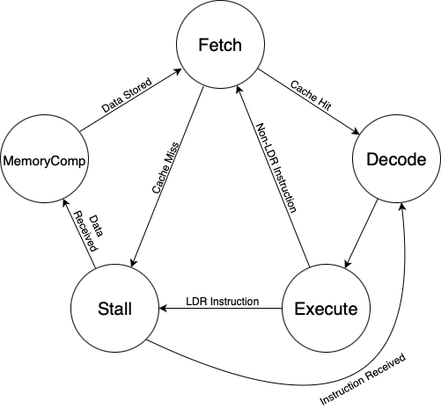

Data Handling Design
To truly emulate the CPU/Cache/RAM interaction, a new CPU component, the DataAccessManager, is used as a middleman to manage components and place data and addresses in the appropriate positions. The CPU itself only ever interacts with the DAM. This does mean that, in a slight break from reality, the L1 Cache is not built into the CPU object itself, but this was thought to be necessary to keep the structure as simple, readable and efficient as possible. The DAM handles two levels of cache, L1 and L2, each of different sizes, and with L1 having priority. The DAM organises dataflow between the caches, the CPU, and the memory buses, and allows for cascading data to flow from L1 into L2 in the event of an overwrite in L1.
The DAM also manages memory interaction.
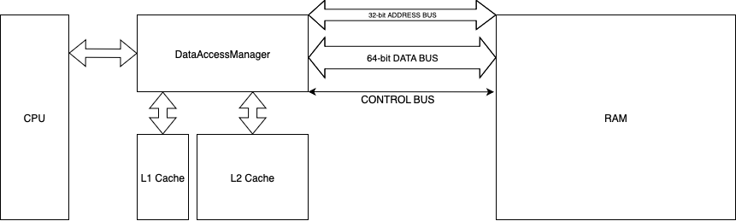
Both cache modules are built to a LRU format, using a queue to keep the most relevant data.

IPC Data Protocol – WORK-IN-PROGRESS

Dashboard to Emulator Messages
Message | String Format
Get Memory Data from Location | GET//<Memory Address>
Increase Clock Speed | INC_CLK
Decrease Clock Speed | DEC_CLK
Set Clock Speed | SET_CLK//<Val>

Emulator to Dashboard Messages
Message Type | String Format
Update Register Value | REG//<Reg Num>//<Val>
Update State Value | STATE//<State No.>
Update Instruction Values | INSTR//<Current Instr Hex>//<Incremented Instr Hex>
Return Memory Data | RAM//<Memory Address>//<Memory Data>
L1 Cache Utilisation | L1_UTIL//<Val>
L2 Cache Utilisation | L2_UTIL//<Val>

